CS 255 System Design Document Template

UML Diagrams

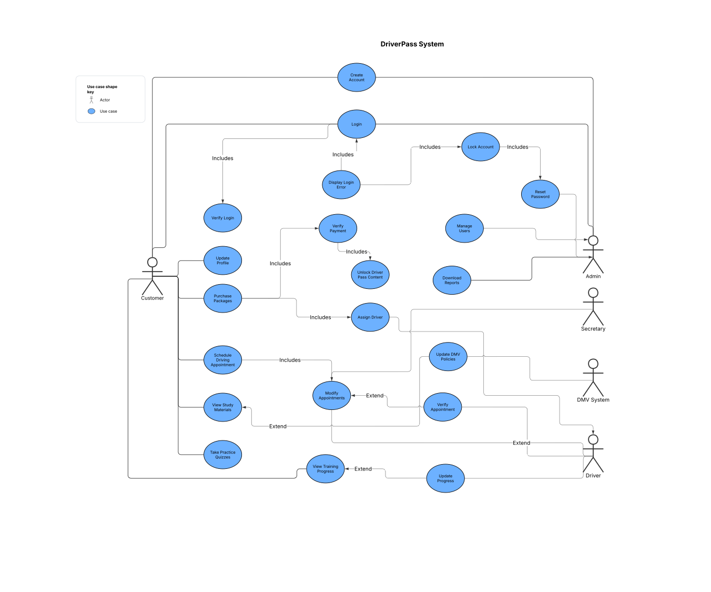
UML Use Case Diagram

UML Activity Diagrams

Login or Register
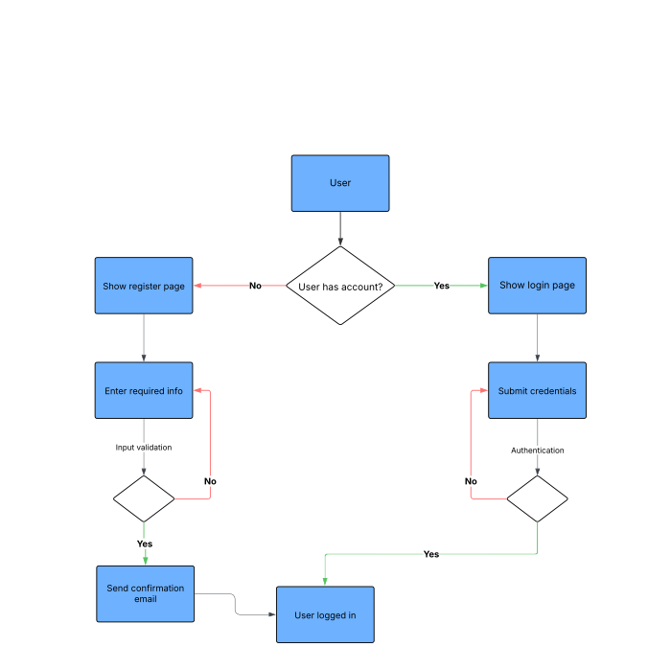

Payment of package processing
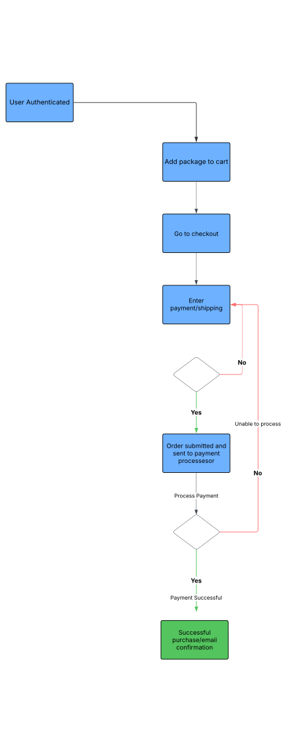

UML Sequence Diagram - Payment of package processing

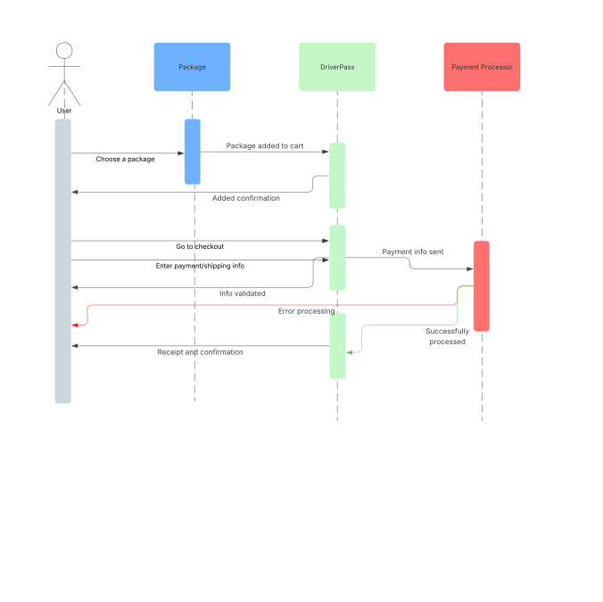

UML Class Diagram
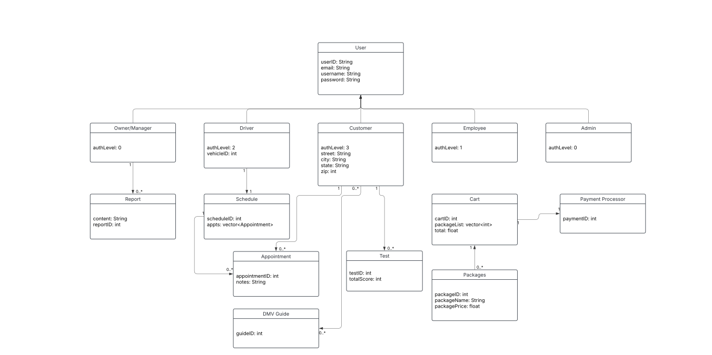

Technical Requirements

Hardware Requirements
- A dedicated server to host the website and database
- Stable and dependable internet connectivity
- Sufficient storage capacity for website files and database content
- Desktop or mobile devices to allow users to access the site
- A configured firewall to protect website ports and network traffic

Software Requirements
- Windows Server (recommended) to ensure system reliability and performance
- SQL Server (recommended) as the primary database management system using a stable release
- Backup solutions for both website files and database data
- A web server platform such as Apache to handle web traffic
- Security software to defend against malware and other cyber threats

Geographic Considerations
- Ensure the website is accessible to users across the United States
- Host the website and database on secure data center infrastructure
- Position the server in a centralized location to improve performance and user accessibility

